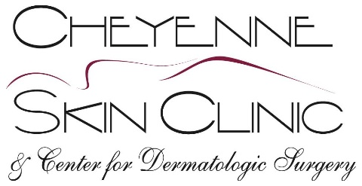
Sandra Surbrugg, M.D., Julie Neville, M.D., Mary Cole, M.D., Paul Massey, M.D.,
Krystal Massey, M.D., Heather Roberts, FNP-C, Caitlyn McCue, P.A., Alissa B. Aylward, PA-C,
Michelle Dowling, DNP, Ashely Badgley, PA-C, Karen Gafford, PA-C

Date: __________________________________

Patient: _________________________________________ DOB: ________________________

Address_________________________ City_______________ State___________ Zip________

Hereby Authorize:_______________________________________________________________

_______________________________________________________________

_______________________________________________________________

To release to: __________________________________________________________________

__________________________________________________________________

__________________________________________________________________

Copies of my medical records to include _____________________________________________

______________________________________________________________________________

Dated from___________________________________ to________________________________

Please note: A $50.00 payment is required for records going to (i.e. attorneys, insurance, disability, or other sources). However, no fee will be charged if the records are sent directly to another continuing care provider. (i.e. physician, hospital, or clinic). Copies of records will be available in 10 to 14 business days.

____________________________________________ _____________________________________
Signature Witness
DERMATOLOGY DERMATOLOGICAL SURGERY DERMATOPATHOLOGY
123 WESTERN HILLS BOULEVARD CHEYENNE, WY 82009
307.635.0226 800.736.0226 FAX 307.635.1924
WWW.CHEYENNESKINCLINIC.COM

